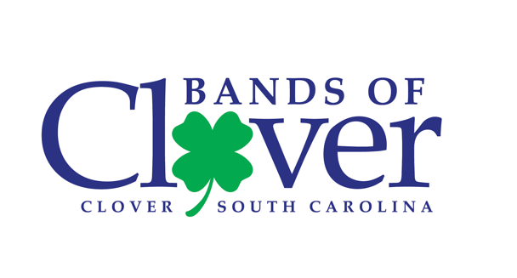

Band Camp Schedule 2022

PRE-CAMP – July 18th – 22nd

Monday Tuesday Wednesday Thursday Friday
PERCUSSION (9-5) PERCUSSION (9-5) PERCUSSION (9-5) PERCUSSION (9-5) NOTHING
GUARD (2-6) GUARD (2-6) GUARD (2-6) ALL WINDS (5-9)
All WINDS (5-9)

WEEK #1 – July 25th – 29th

Monday Tuesday Wednesday Thursday Friday
WINDS/PERC (9-5) WINDS/PERC (9-5) WINDS/PERC (9-5) WINDS/PERC (9-5) NOTHING
GUARD (2-9) GUARD (2-9) GUARD (2-9) GUARD (2-9)
*Meal breaks @ 12:00 & 5:00 bring your own bag meal

WEEK #2 - August 1st – 5th
Monday Tuesday Wednesday Thursday Friday
FULL BAND (1-9) FULL BAND (1-9) FULL BAND (1-9) FULL BAND (1-9) NOTHING
GUARD (2-9) GUARD (2-9) GUARD (2-9) GUARD (2-9)
*Dinner @ 5:00 – Provided by Boosters

POST CAMP - August 8th – 12th
Monday Tuesday Wednesday Thursday Friday
FULL BAND (5-9) FULL BAND (5-9) NOTHING FULL BAND (5-9) NOTHING

- All students are required to have their own personal insulated water jug for band camp! Please make sure your name is on it. (1/2-gallon min.) Plan now!

BAND CAMP CHECK LIST

_____ Tennis shoes... no sandals allowed!
_____ Socks ...mandatory!! (Bring an extra pair!)
_____ Shorts (no long pants!)
_____ T-shirts (white!)
_____ Brimmed hat (the bigger the better!)
_____ Sunscreen YES!
_____ Water jug (1 gallon recommended!)
_____ Sunglasses (HIGHLY RECOMMENDED!)
_____ INSTRUMENT!!
_____ 1 case (2-12 packs) of sodas (name brand please!)
_____ MUSIC… MEMORIZED!
_____ A GREAT ATTITUDE!

- White T-Shirts are MANDATORY during all outside rehearsals. The can have writing/logos, but they must be 90% white. This will help you keep cooler and the staff to read forms better. MANDATORY… means NOT OPTIONAL!

- A Hat (with brim), sunscreen & tennis shoes w/socks are REQUIRED whenever you are outside during band camp. Please plan to bring an extra pair of socks in case yours get wet. REQUIRED… also means NOT OPTIONAL!

- All students are asked to bring 1 case (2-12packs) of soda and 1 donation item Pop-Tarts (12 ct box or larger), Nutri-Grain Bars, Granola Bars or Powdered Gatorade with them by August 2nd. This will help us provide drinks during the season when needed. Please write your name on your soda/items!

- WORK ON YOUR MUSIC. 10th -12th graders should work to memorize the show music before coming to camp. Rookies, do your best to do the same… we will help you when camp starts. Music will be available via your SMARTMUSIC account! Mark anything you feel necessary on your music. Having your music memorized before coming to camp helps tremendously with learning drill!!

